# 

# Retrieving Documents in Elasticsearch

## 1. Introduction

In this section, we will retrieve a document that was previously added to the Elasticsearch index. Retrieving a document requires knowing its ID. If the ID is not known, searches can be performed based on criteria, which will be covered later in the course.

## 2. Retrieving a Document by ID

1. To retrieve a document, the following details are required:

- The index name where the document is stored.

- The unique ID of the document.

2. Use the HTTP verb 'GET' to retrieve the document.

3. The endpoint for the request is the same as when the document was added, demonstrating how HTTP verbs define the action.

4. Example: Retrieving the document with ID 100 from the 'products' index.

GET /products/_doc/100

5. Response Details:

- If the document exists, the JSON object returned will include the '_source' key, containing the document data.

- If the document does not exist, the **'found'** key will be set to 'false', and **'_source'** will not be included in the response.

6. **Example Response** (**Document Found**):  
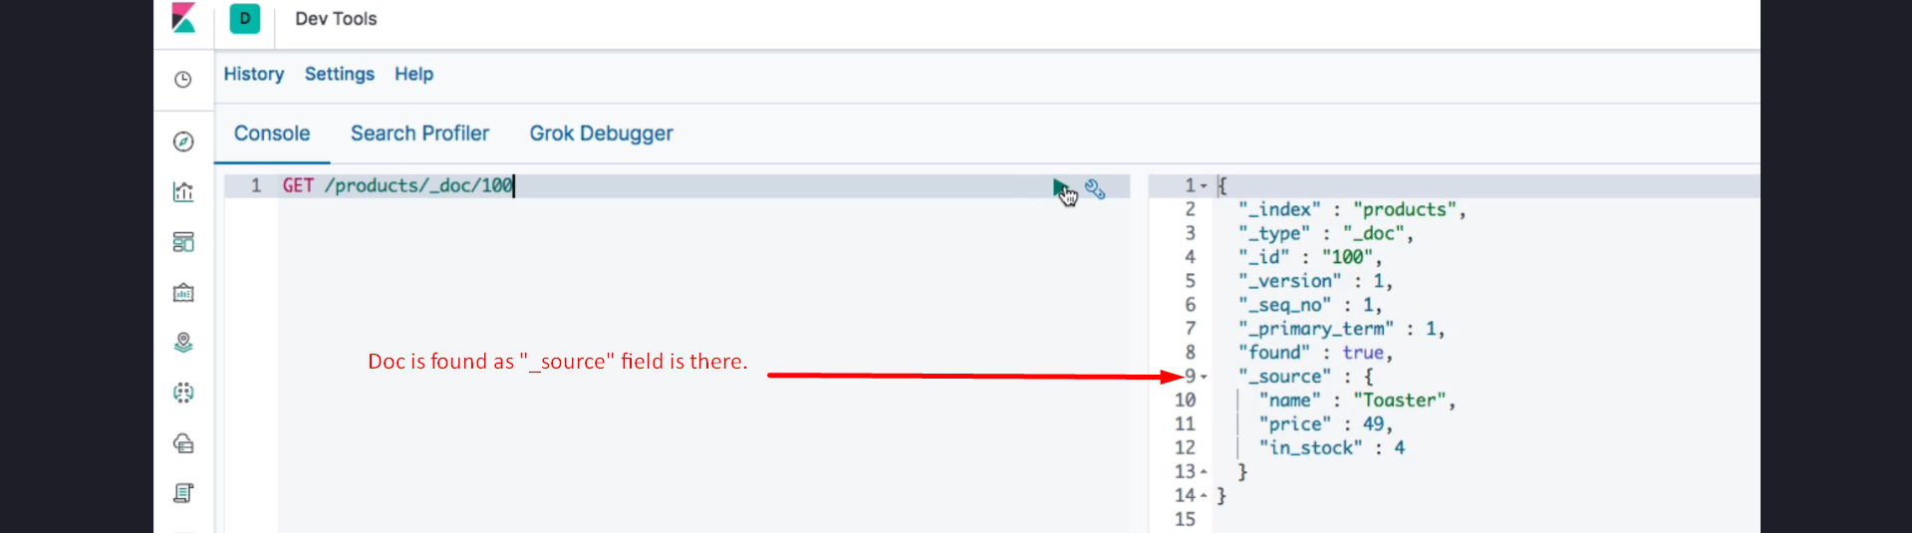

{  
 "_index": "products",  
 "_id": "100",  
 **"_source":** {  
 "name": "Custom Product",  
 "price": 199.99,  
 "in_stock": false  
 }  
}

7. Example Response (**Document Not Found**):

{  
 "_index": "products",  
 "_id": "100",  
 **"found": false**  
}

## 3. Summary

1. Retrieving a document requires using the 'GET' HTTP verb and the document's ID.

2. The '_source' key in the response contains the document data if it exists.

3. If the document is not found, the response will indicate this with the 'found' key set to 'false'.